Hannah Lehmann
Course# AED 4200 Spring 2013
Computer Graphics for Art Educators
Instructor: Patricia Whittington
Contemporary Delft Tile Design

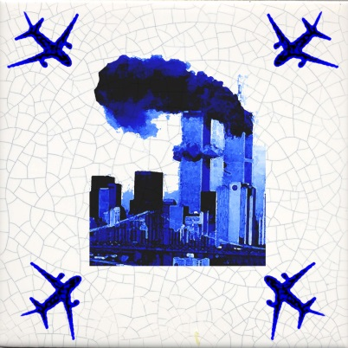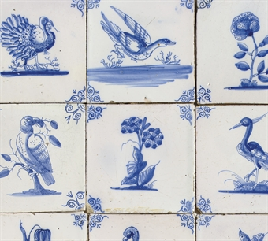

- CLASS: High School
- TIME NEEDED: Two one hour classroom periods
- ART BACKGROUND RELATED TO THE LESSON PLAN:
The decorative arts is a term used to describe the design and manufacture of functional objects. One such object is the Delft tile, a blue and white ceramic tile which was incorporated into homes throughout Holland beginning in the late 16th century. During the Dutch Golden Age, the Dutch East India Company traded with the China and imported millions of pieces of Chinese porcelain in the early 17th century. Dutch artisans were inspired by the motifs/designs of these Chinese ceramics and began incorporating similar images in their own work. In addition, Delft potters incorporated images of everyday life, natural history, and biblical tales. The Delft potters made tiles in vast numbers (estimated at eight hundred million) over a period of two hundred years. Many Dutch houses still have tiles from the 17th and 18th centuries. The imagery and monochromatic coloring of Delft tiles is frequently incorporated into modern design. Ceramic artists continue to find inspiration in Delft design, as do furniture designers, fashion designers, and architects.
- SUBJECT: Contemporary Delft Tile Design
- EQUIPMENT/AV MATERIALS: computer, Photoshop software
- SUPPLIES: flashdrive/other storage device
- OBJECTIVES:
- Students will learn about the history of delft tiles and will both learn and describe how similar designs can be created using appropriate vocabulary associated with Photoshop and graphic design. (academic skills/comprehension)
- Students will use Photoshop to alter digital images of current historical events in their creation of a digital Delft tile. (craftsmanship skills/synthesis)
- Students will explain vocally and in writing their reasoning behind their design and visual image choices that they used in their project. (higher cognitive skills/comprehension)
- STANDARDS:
Content Statement from the Ohio Deptarment of Education Visual Art Standards
- 1PE Examine the context details of visual imagery and explain the social and cultural influences on the images.
  - The subjects of historical Delft tiles depict the following subjects: natural history, biblical stories, and daily life. Students will explore how these same themes would be portrayed differently in respect to contemporary society.
- 2PE Describe sources visual artists use to generate ideas for artworks.
  - Ideas in the decorative arts are often influenced by popular culture, we see this in the use of tulips in Delft tiles.
- 5PE Explore the application of technology to the production of visual artworks.
  - Instead of physically painting a tile, we will use Photoshop to create our design. This design could then be printed industrially and applied to a tile.
- 5PR Understand and demonstrate how to access available digital tools and innovative technologies to create and manipulate artwork.
  - Students will use a number of Photoshop tools to alter imagery in the creation of their Delft tile.
- 4RE Explain the role of innovative technologies in the creation and composition of new media imagery.
  - Students will explain how the different functions of Photoshop were used to create their digital image
State Standards
- English/Language Arts Standards
- Acquisition of Vocabulary: Exposure to language-rich situations, use context clues, apply word analysis skills, proficient in application of knowledge of words and specialized vocabulary.
  - Students will participate and write about how photoshop and the elements of art and design are incorporated into their work
2. Social studies Standards
- People in Societies: Students use knowledge of perspectives, practices and products of cultural, ehtnic and social roups to analyze the impact of their commonality and diversity within local, national, regional and global settings.
  - Students will incorporate an aspect of contemporary history into their design.
- ACADEMIC LANGUAGE
- Art History: Delft Tiles, Motif, Balance, Repition, Monochromatic, Decorative Arts, Symmetry
- Digital: Color Balance, Magic Wand Selection, Rotation, Transformation, Resizing, Eraser Tool, Filter Gallery, Opacity, Merge Layers

- LEARNER OUTCOMES:
- Students will increase their competency using Gallery Filter, Transformation, Color Balance, and Magic Wand tools available in Photoshop, as well as, their understanding of other features in Photoshop previously used.
- Through their choice of images and their written assessment that describes the reasoning behind their selection, students will display an understanding of both design and contemporary history.
- SAFETY CONSIDERATIONS: Keep food and drink away from computers. Install firewalls to prevent inappropriate interenet sites from being accessed.
- ALTERNATIVES TO THE LESSON: Students may complete this assignments as a 2D work of art, either as a painting or drawing. They may also work with the ceramics class and print their digital image onto a decal that can be fired onto a ceramic tile.
- PROCEDURE
- Students will be introduced to the concept of decorative artists, specifically a brief history of Delft tiles and their design. Together we will identify and analyze the images, color palette, and design of the Delft tiles and discuss how these images could be achieved using Photoshop.
- How Delft imagery is incorporated into contemporary art and design will also be discussed.
- Students will be provided a crackle tile background onto which they will be instructed to create a design that incorporates a border motif and central image depicting an aspect of contemporary history.
- Aspects of Photoshop that have not been covered, such as color balance, will be covered at this time
- Students will be reminded to save their work throughout the class period.
- Upon completion, images will be projected and discussed in a group critique.
- Students will take home a post assessment regarding their project that they will need to return at the beginning of the next class

- EVALUATION OF STUDENT WORK
 | Does not meet expectations (0-1) | Meets Expectations (2-4) | Exceeds Expectations (5)
Image  Did the student complete a digital graphic containg both a central image and a border motif? | The work is not complete. Either unfinished or lacking a component. | The work is complete and contains the minimum requirements. | The work is complete and incorporates both aspects, if not more, in a well thought out manner.
Research  Did the student pick a theme that is relevant to contemporary history? | The central theme does not relate to contemporary history. | The central theme relates to contemporary history, but the student is not sure why. | The student chose a central theme that both relates to contemporary history and can be described by the student
Presentation  Did the student understand how to use Photoshop to complete the assisngment? | The student did not understand the assignment and did not complete their work. | A basic understanding of Photoshop was achieved and the assignment was completed. | The student exhibited a thorough understanding of the Photoshop elements covered in this assignment.

1pt Grading Scale 15-13=A, 12-9 = b, 8-5= C, 4-0= F

