AED 4200/Applied Computer Graphics Art Educators, Spring 2013
Hannah Lehmann

Modern History Delft Tile

Delft tiles were used throughout Europe decoratively in the home. They frequently depicted images of nature, allegories, and/or history. They almost always included a repeating motif in their corners or borders which would assist in visually unifying the tiles when displayed together.

Inspired by the history and design of Delft tiles, we will produce a digital work of art that visually comments on an aspect of Modern History while incorporating aspects of a traditional 16th century Delft Tile. Aspects of Photoshop that will be utilized include the Magic Wand, the Filter Gallery, Transformation, Color Balance tools

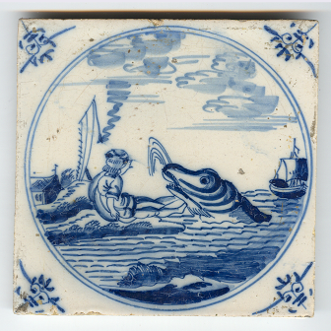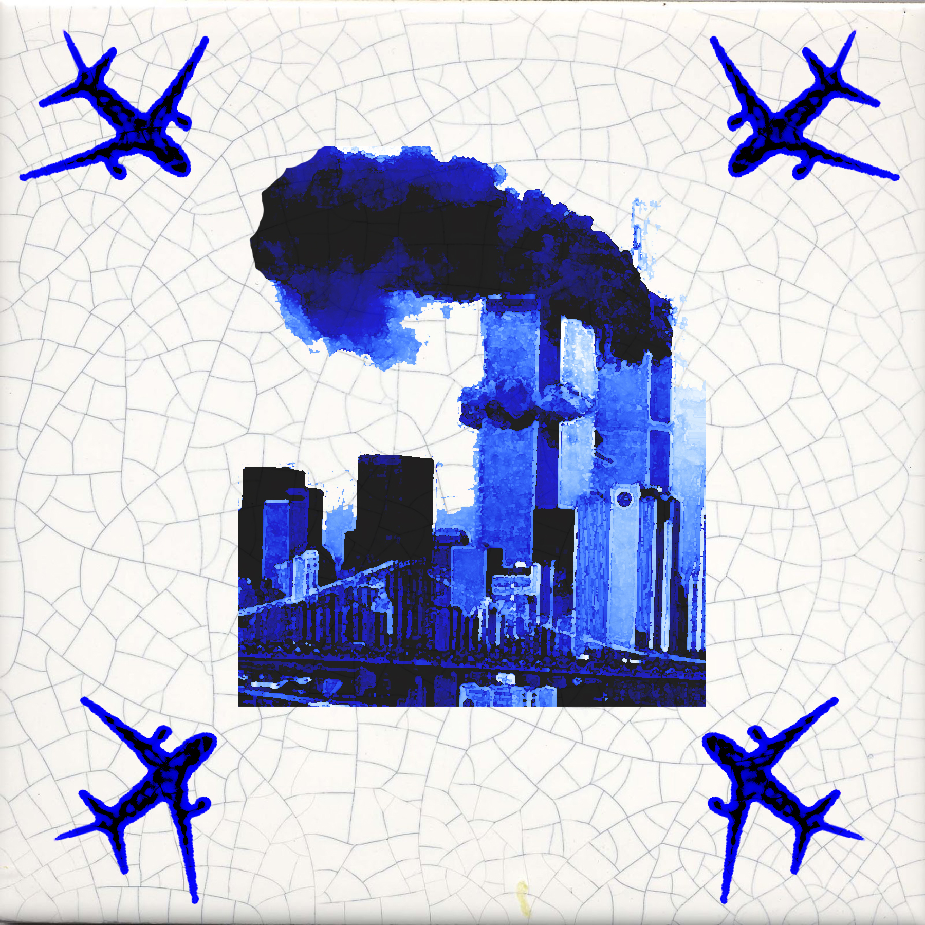
Historical Delft Tile Modern History Delft Tile

